Why do I need to buy and AED
it may be your life the AED saves…………………

An AED or automatic external defibrillator is a medical device designed and recommended the use by almost anyone. Its function is to deliver a powerful electric shock to the heart of somebody who has collapsed. It is the only treatment for somebody in this condition and speed is of the essence. No doubt you've seen a similar defibrillator being used many times on television programmes.
To date the British government have purchased and installed around 5000 AED's across the country with the aim of getting a defibrillator to a victim within 3 minutes. Around 300,000 people a year die from sudden cardiac death, often with no previous history and no warning. You will find them already installed in airports, railway stations, police cars, homes, shops and pubs factories and offices.
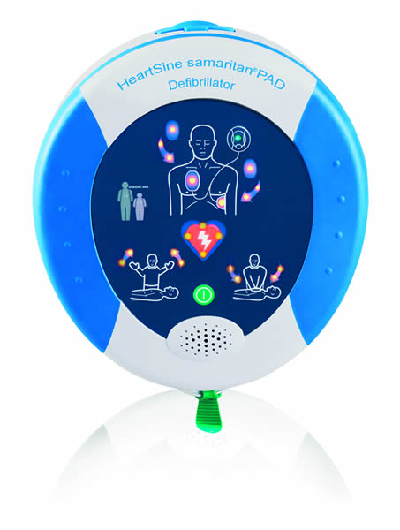
The biggest concern anybody has when they consider whether to purchase an AED is whether they can do any harm. The simple answer is no. AED's are designed to be instinctively easy-to-use and will only operate if the patient is in one of two potentially fatal cardiac arrhythmias. Every other medical condition from a simple faint to something more serious will not allow the device to deliver a shock.
So, every minute that is wasted in delivering a shock to patient in cardiac arrest their chances of survival deteriorate by at least 10% so if you think you can get to the patient before an ambulance does, you've answered the question of whether you need to buy an AED.
The Heartsine shown here is incredibly instinctively easy-to-use. It has a long life no maintenance battery and checks itself daily. The Heartsine will guide you with what to do using voice and visual commands. All you need to do when you find the patient in a collapsed state is attach two self adhesive electrodes to their chest, switch the machine on and listen.
Using a defibrillator does not mean that you don't need an ambulance, you still need medical support but you are giving the patient the greatest possible chance of survival and the paramedic the greatest chance of delivering that patient to hospital alive.
AED's have dropped dramatically in price over the last twenty years and the leading defibs are now available at a little over GBP800. A small price to pay for peace of mind and an even smaller price to pay for saving someone's life.
Courses are available to teach you CPR and AED use should you require this. There is an additional cost for this but it is an extensive course for your staff.
References:
http://www.resus.org.uk/pages/respDfib.htm
http://www.resus.org.uk/pages/AEDtrnst.htm

